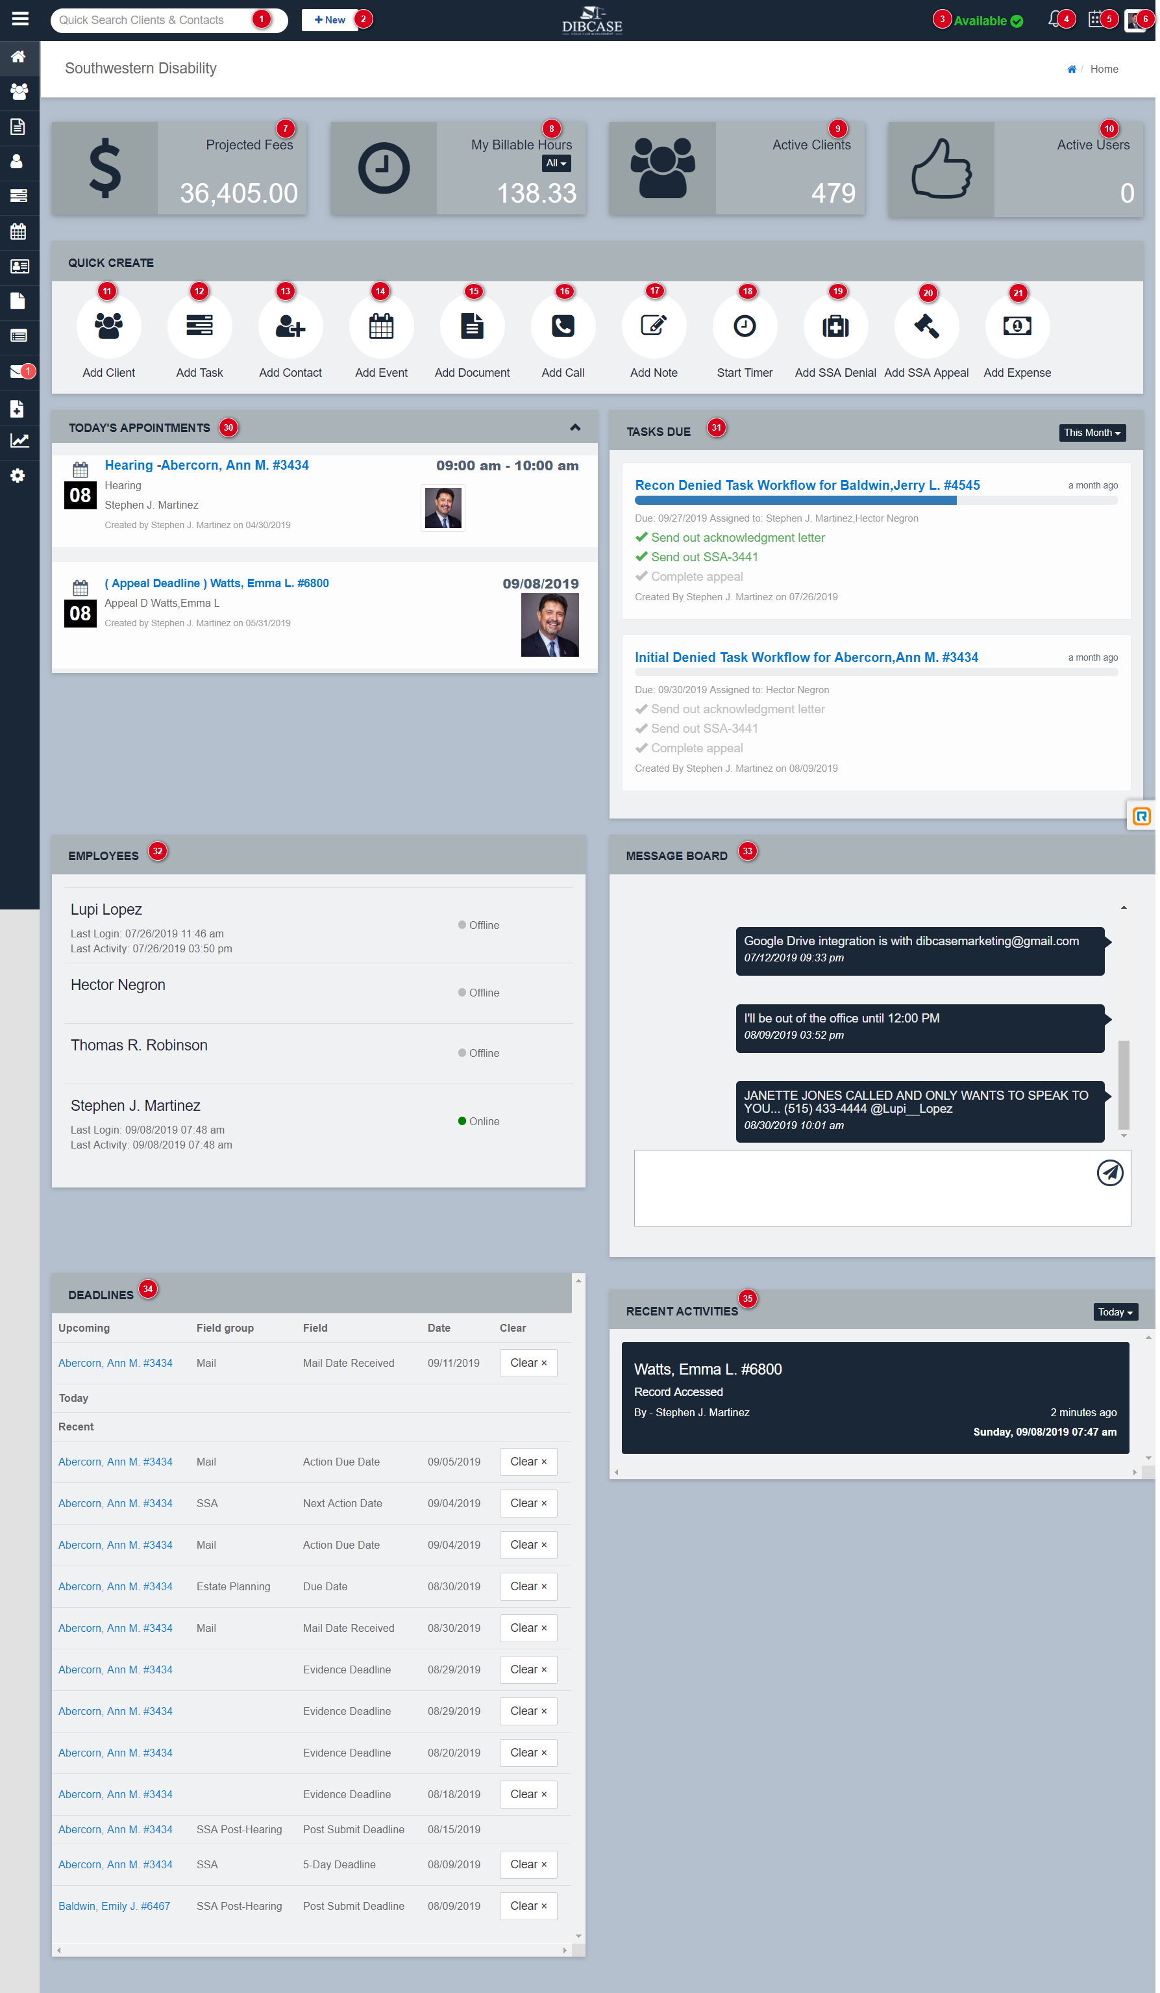
Number | Title | Body | Links
1 | Search | Master search box. You can search clients and contacts by:  - Last Name  - First Name  - Last “4” of SSN  - Contact “Company”
2 | New Button | This button allows you to start actions and automations from any page in the application.
3 | User Availability | Set your availability with this panel. Your status will appear in the “EMPLOYEES” dashboard panel if you are “visible” on the Dashboard. See “Employee List” page to toggle visibility for individual users.
4 | Notifications | *Not enabled
5 | Task Notifications | *Not enabled
6 | Menu Items | My Profile Page  Firm Settings Page  Log Out
7 | Projected Fees | The total of all fees projected on all SSA claims. Set in the “Fees and Awards” accordion on SSA claims.
8 | My Billable Hours | The total billable hours that you have generated for the selected time period
9 | Active Clients | The number of your firm’s active clients as opposed to prospects, leads, closed, etc.
10 | Active Users | The number of other firm users currently logged into Dibcase
11 | Add Client | This “Quick Create” option opens the “New Intake Window” to add new clients.
12 | Add Task | This “Quick Create” option redirects to the “Task List Page” and opens the “New Task” window.
13 | Add Contact | This “Quick Create” option redirects to the “Contacts List Page” and opens the “Add Contact” window.
14 | Add Event | This “Quick Create” option redirects to the “Calendar Page” and opens the “Add Event” window.
15 | Add Document | This “Quick Create” option redirects to the “Document Template Editor Page” you can also go to the “Document Manager” page to create a document | https://app.dibcase.com/#/dashboard/document-manager
16 | Add Call | This “Quick Create” option opens the “Add Call” window. This will allow you to log a call without visiting the client’s page and documenting a call. Select “Incoming” or “Outgoing” to document the origin of the call. Select the client the call refers to and any claim to associate the call with. Describe the nature of the call and add an associated billable time value.
17 | Add Note | This “Quick Create” option opens the “Add Note” window. This will allow you to log a note without visiting the client’s page and documenting an action. Select the client the note refers to and any claim to associate the action with. Describe the nature of the call and add an associated billable time value.
18 | Start Timer | This “Quick Create” option opens the “Add Timer” window. This will allow you to log time associated with a client or claim.  Steps:  - Select Client  - Select Claim/Matter  - Activity (i.e. phone call, case review)  - Add Description  - Press “Start”  - When finished, press “Stop”  - Close the window with the “X” button on top right of panel  - On the “Are you sure?” window select “Save” “Cancel” or “Delete”
19 | Add SSA Denial | This “Quick Create” option opens the “Add SSA Denial” window. This workflow automation allows you document a denied SSA claim.  Steps:  - Select Client  - Select Claim  - The current claim level should appear  - Select “New Claim Level”  - Add the Denial Date of the notice or decision  - The “ADD” box defaults to 60 days  - The Appeal Deadline will auto-calculate the “Denial Date” plus the “ADD” value  Add an optional Task Workflow Template if so desired.
20 | Add SSA Appeal | This “Quick Create” option opens the “Add SSA Appeal” window. This workflow automation allows you document a denied SSA claim.  Steps:  - Select Client  - Select Claim  - The current claim level should appear  - Select “New Claim Level”  - In the “Appeal Process Date” field, add the day the appeal was processed  - Add the “Re-Entry Number” to add complete the note entry  - The default time for processing appeals is 30 min.
21 | Add Expense | This “Quick Create” option opens the “Add Expense” window  Steps:  - Select Client  - Select Claim / Matter  - Add the Vendor / Provider  - Add the Item / Service  - Add the expense “Amount”  - Add Note  Note:  Expense entries will appear in the “Ledger” tab on the client’s page.
22-29 | RESERVED | RESERVED
30 | TODAY’S APPOINTMENTS | Show all appointments for current calendar date. Also show appeal deadlines for SSA claims.
31 | TASKS DUE | Show all tasks due for current selected timeframe  Options:  Today  This Week  This Month  Past Due
32 | EMPLOYEES | Show all employees whom visibility is enabled
33 | MESSAGE BOARD | Show’s internal message between firm employees
34 | DEADLINES | This panel shows all “Custom Fields” that are designated as “Deadlines” in the custom field editor
35 | RECENT ACTIVITIES | This panel show all recent activities related client and claims activity.

